**ASSIGNMENT SUBMISSION COVER SHEET**

**Student Id: cse24-018**

**Student names: Goodwill Ditlhako**

**Student email: cse24-018@thuto.bac.ac.bw**

**Cohort: cse24**

**Assignment title: The BANKING System**

**Date of submission: Friday 19 september**

**Programme of Study: BSC**

**Year of Study:2025**

**Intellectual property statement**

**By checking the box below, I certify that this assignment is my own work and is free from plagiarism. I understand that the assignment may be checked for plagiarism by electronic or other means and may be transferred and stored in a database for the purposes of data-matching to help detect plagiarism. The assignment has not previously been submitted for assessment in any other unit or to any other institution.**

**I have read and understood the Botswana Accountancy College plagiarism guidelines policy.**

* **Agree                                                              19/09/2025**

**Signature……G.M.K.DITLHAKO………………………. Date……………19/09/2025…………………………….**

Requirements Elicitation  
  
Interview with Tutor Themba Moeng  
THURSDAY, 1000hrs  
  
Functional Requrements-This describes how the systems should do  
  
Questions related to Functional Requirements  
  
Q:What customer details should be entered into the system?  
A:Customer name,Surname,address and accounts  
  
Q:Does the customer need to login before accessing the system?  
A:For security reasons, yes  
  
Q:Should there be a withdrawal limit?  
A:No  
  
Q:Should the interest be automatically charged or a staff member should add it?  
A:It should be automatically credited  
  
NON FUNCTIONAL REQUIREMENTS  
  
Q:What is an acceptable response time for a transaction?  
A:3 seconds  
  
Q:Should the system have a database?  
A:For now we dont need to but at a later stage  
  
**Sructural UML Modelling**

**USE CASE DIAGRAM**

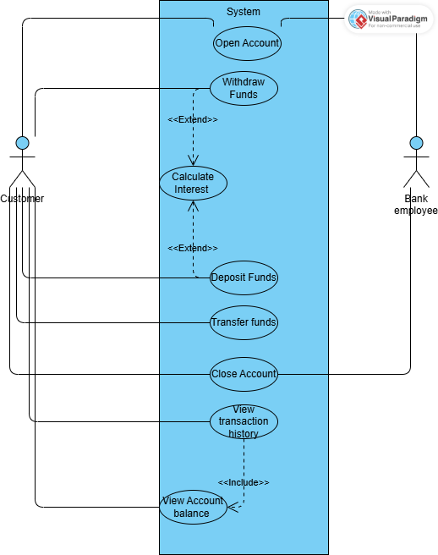

**CLASS DIAGRAM**

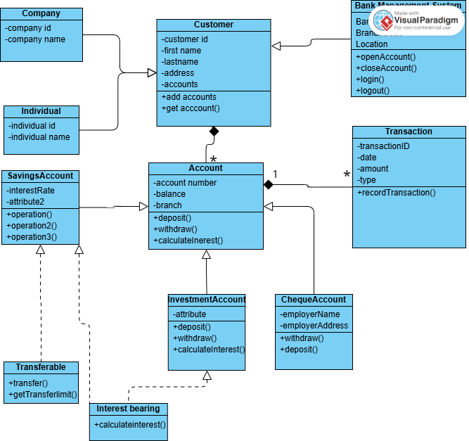

**BEHAVIOURAL UML Modelling**

|  |
| --- |
|  **|

**DEPOSIT**

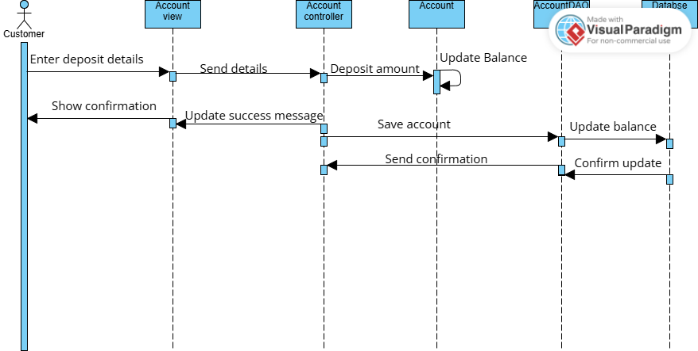

**STATE DIAGRAM**

**MEETING LINK**

<https://mybac.sharepoint.com/:v:/s/20252026cse202objectorientedanalysisanddevelopmentwithjav/ETK2KNDOJNNCgI3WOcFy_XUB57nHHAzNSlG9JaieWIF_jg>